Quarch Technology Ltd

AN-017

Application Note

QPS automation with FIO

For use with:

**XLC Power Modules  
HD Power Modules**

**Quarch Power Studio (QPS)**

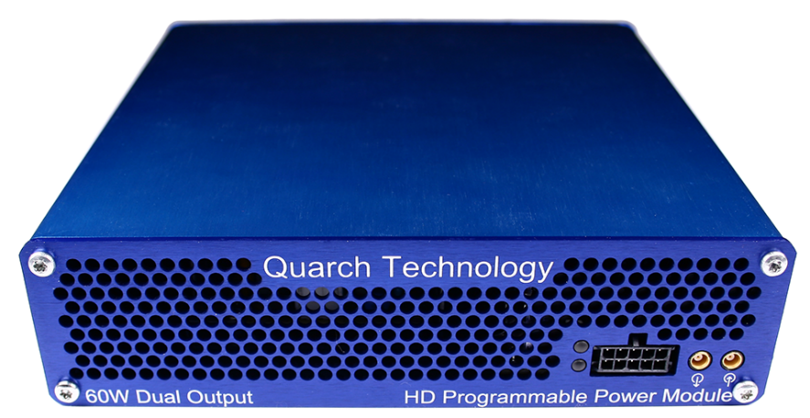

# Change History

|  |  |  |
| --- | --- | --- |
| 1.0 |  | Initial Release |
| 1.1 | Feb 2019 | Updated to Python 3.x |
| 1.2 | May 2019 | Updated for quarchpy 2.x |
|  |  |  |
|  |  |  |

Contents

Change History 2

Introduction 4

Modules Supported 5

System Supported 5

Application Note Example Files 5

Installation and setup 5

Python install 5

QuarchPy library install 6

Java install 8

QPS install 8

FIO install 8

Power module setup 9

Running the example 10

# Introduction

Quarch Power Studio (QPS) is a unique system for recording and analyzing power consumption of storage devices. This application note demonstrates the ability to automate QPS and bring in user data from another source. In this example, FIO is used to drive traffic to a device and plot both power and performance as part of a fully automated test.

# Modules Supported

XLC power modules

* QTL1824 (QTL1824-02A modules do NOT support streaming, but can be upgraded by Quarch)
* QTL1847

HD power modules

* QTL1995
* QTL1999

# System Supported

This example is written and tested on Windows, though could be used on MacOS and Linux as long as FIO is installed.

It currently requires Python 3.x

## Application Note Example Files

The **AN-017.zip** should be extracted to your preferred location.

|  |  |
| --- | --- |
| scriptFIO.py | Main python file to execute |
| jobFileExample.fio | FIO Example configuration file |

# Installation and setup

## Python install

If you do not already have Python 3.x installed, download and install it from:

<https://www.python.org/downloads/>

Under Windows it is helpful to make sure the Python installation directory and PythonXX\Scripts are included in the PATH environment variable. See:

## [https://docs.python.org/3/using/windows.html#excursus-setting-environment-variables](https://docs.python.org/3/using/windows.html" \l "excursus-setting-environment-variables)

## QuarchPy library install

The Quarch Python package can be installed from the Python web repository (assuming you have internet access) or via the download from our website.

Quarchpy will also install a version of Quarch Power Studio

### Web Install

From the command line:

**>pip install quarchpy**

If this fails, your path to “pip” may not be set, you can instead run:

**>python –m pip install quarchpy**

### Local Install

If you want to install from a downloaded folder, ensure the folder is unzipped to a local disk, navigate to the folder containing the setup.py file and run (noting the ‘.’ on the end):

**>pip install quarchpy .**

If this fails, your path to ‘pip’ may not be set, you can instead run:

**>python –m pip install quarchpy .**

### Upgrade

If you already have QuarchPy installed, you will get a failure message. If you want to upgrade to a new version, you need to add the ‘--upgrade’ command:

**>pip install --upgrade quarchpy**

The --upgrade command can similarly be used in any of the other examples, to load from a local install folder.

## Java install

Check that the Java JRE is installed

You can find install instructions and files here:  
<http://www.oracle.com/technetwork/java/javase/downloads/index.html>

## QPS install

Current versions of QPS are provided as a portable (non-install) .jar file

The latest version can be downloaded from here:  
<https://quarch.com/products/quarch-power-studio>

## FIO install

QuarchPy doesn’t ship with FIO. Follow the installation procedures described in <https://github.com/axboe/fio> according to your system and make sure the command *fio* is available in the system’s shell.

## Power module setup

Connect the power module to the test PC and the output of the power module to the drive under test.

Customer Drive

USB/LAN Connection

Power Module

Customer Test PC

# Running the example

QuarchPy ships with *scriptFIO.py* and supports two forms of integration with FIO:

* If you wish to use FIO without a file, you can populate the variable arguments with valid FIO arguments and the user will be prompted to select a target folder from a GUI window.
* For the users familiar with FIO configuration files, QuarchPy is able to import all settings from a .fio file.

The scriptFIO.py file demonstrates both options in sequence.

Before running this example, make sure you have a valid .fio file (as described in FIO’s manual) and its path is declared as the variable *fioFile*. You can use the *jobFileExample.fio* file provided with AN-017.

The variable *arguments* should be populated with valid FIO arguments (as described in FIO’s manual).

* You will be prompted to select the Quarch power module you want to connect to.
* If the power module’s outputs are disable, you will be prompted to enter a voltage mode (3V3 or 5V). If they are on from a previous run, the script will proceed.
* You will be prompted to enter an averaging rate. Pressing *enter* should use the default value of 32k.
* You will be prompted to select a target folder to run on, ensure that you select the correct drive (the one connected to Quarch’s power module), or the FIO test may erase important data!
* The script will now launch Power Studio, this may take a few seconds
* The script will iterate through every job described in the .fio file or the *arguments* variable.
* As each FIO run is executed, the script will:
  + Display the real time power consumption.
  + Annotate the start and end of each test.
  + Parse the FIO results and add the second-by-second performance data onto the chart.

